Classical and fuzzy neural networks for signal processing and measurements

Stanisław Osowski

Institute of the Theory of Electrical Engineering and Electrical Measurements,
Warsaw University of Technology
and

Institute of Electronic Fundamentals, Military University of Technology, Warsaw

Abstract
The paper presents the tutorial on the recent trends in neural networks theory and its applications in signal processing of the measured data. The main types of the feedforward neural and neuro-fuzzy networks are presented and discussed. The multilayer perceptron, radial basis function network, the self-organizing Kohonen network, hybrid networks and neuro-fuzzy networks of the supervised and fuzzy self-organization belong to the most often used structures. The learning algorithms and few typical applications of these networks are given and discussed in the paper.

1. Introduction

Neural and neuro-fuzzy networks [3,4,5] perform today very important role in the engineering, especially instrumentation and measurements. Classical neural networks, applying crisp boolean logic and neuro-fuzzy networks, making use of the fuzzy set rules are regarded now as the most robust approaches to the non-linear signal processing. Irrespective of the way of implementation of the neural networks they perform the role of the universal approximator [8,14] in the multidimensional space, mapping the input space $x∈R^{N}$ into the output space $y∈R^{M}$ in the functional form y=f(x).
The last nonlinear multidimensional relation covers many particular applications of neural networks. They include the classification of the data, identification of the nonlinear dynamic plants, estimation and prediction tasks, correction of the non-linear characteristics of the devices, calibration of the measuring units, lossy compression of the data and many other particular applications [1,3,6].
The neural networks belong to the so-called artificial intelligence techniques. The most important property of the neural network is its generalization ability, i.e. the ability to generate the right response to the excitation x not taking part in the learning stage, but sharing the same features as the learning data [3]. This is the unique property of neural networks, not applicable to the other electronic devices. The other important point is the massive parallel connectionism among the neurons in the network. All neurons of one layer are connected with the other neurons in the next layer. The loss of some connections usually does not destroy the whole network. Its function is insensitive (to some degree) to the existence of these connections.
Many different implementations of neural networks can be recognized and classified. The most important are the feedforward and feedback (recurrent) neural networks [3,6,7]. The multilayer perceptron (MLP) and radial basis function (RBF) networks are the most known representatives of the first group. On the other hand we have also many types of the recurrent networks, such as Hopfield, Hamming, Elman, RTRN, recurrent MLP networks, etc. [6]. Both mentioned above groups belong to the so called supervised neural networks, where the pair of signals: the input vector x and the destination vector d are known at the learning stage.
Another classification takes into account the learning paradigms and split the family of neural networks into two groups: the supervised networks and the self-organizing networks. Among self-organization, where only input vectors x_{i} are known at the learning stage, we can recognize the competitive networks, like Kohonen or hybrid structures and the hebbian (correlation) networks, from which the most representative are the PCA (Principal Component Analysis) and ICA (Independent Component Analysis) networks [1,3,15].
This paper will present and discuss the most important neural networks belonging to the feedforward class. The multilayer perceptron, radial basis function network, self-organizing Kohonen network and hybrid structures will be presented. The recent trends in the neuro-fuzzy implementation of the fuzzy rules will be also discussed. The theoretical considerations will be supported by the examples of practical applications of the neural and neuro-fuzzy networks.

2. The feedforward multilayer network

The multilayer feedforward network, often called also multilayer perceptron (MLP) [3,6] is still the most important neural network. The general structure of it is shown in Fig. 1.

Fig. 1 The structure of the multilayer perceptron

The network is composed of many neurons arranged in the layers. The number of hidden layers may be different, but in most cases only one hidden layer is sufficient. The synaptic connections exist only among neurons of two succeeding layers and the flow of the signals is only feedforward. All neurons in hidden layers are characterized by the sigmoidal activation function, either unipolar $f(u)=\frac{1}{1+\text{exp}\left(−u\right)}$, or bipolar $f(u)=\text{tanh}(u)$, while the output neurons are either sigmoidal or linear. The net signal $u_{i}$ of ith neuron is the weighted sum of the signals incoming to this neuron, $u_{i}=\sum_{j}{w_{\text{ij}}}y_{j}$, where the weights $w_{\text{ij}}$ are associated with the link connecting the nodes j and i (from j to i). Since the weights $w_{\text{ij}}$ are actually internal parameters associated with the neuron, changing these weights will alter the activity of this neuron and in turn of the whole MLP network.
It was found that MLP network is capable to approximate any multidimensional data with arbitrary accuracy [3,14]. To achieve this we have to adapt the weights in such a way that the error measure for all training input-output pairs are minimized. At m output neurons and p training pairs (x, d), where x is the input vector, d - the destination vector and y - the vector of actual output signals, the error function E is usually defined using the euclidean norm as follows

$E=\frac{1}{2}\sum_{j=1}^{p}{‖y_{j}}−d_{j}‖^{2}$ (1)

where the index j is referred to the jth training pattern. In the gradient method of learning we adapt the weights from the cycle to the cycle according to the information of gradient

$w(k+1)=w(k)+ηp(k)$ (2 )
where $η$is the learning coefficient calculated at each cycle and $p$ is the direction vector of minimization, described using the gradient information. In practical implementation of the learning process, the most robust one is the quasi Newton method [3,6], in which

$p(k)=−H^{−1}(k)g(k)$ (3)

with H(k) - the approximated hessian matrix and g(k) - the gradient vector of the error function at kth cycle. Gradient is generated according to the very powerful backpropagation algorithm [3,6]. In such organization of training process the kth learning cycle is composed of three stages:
- determination of the direction vector p(k) using information of hessian and gradient,
- determination of the optimal learning rate$η$ using either the adaptive method or the directional minimization on the direction vector p(k),
- updating the weight vector w according to the rule (2).
After finishing training, the weights are frozen and ready for use in the retrieval mode, in which the vector x put to the input of the MLP network generates the vector y composed of the activities of neurons of the output layer.
The most important feature of the MLP is its generalization ability. As has been proved in [3,6] to acquire this ability, the network should possess as low number of weights as needed to reduce the error function to the appropriate low level and at the same time the number of learning samples should be as high as possible. Such organization of learning will result in statistical processing of the signals and force the network to learn the statistical characteristics of the data rather than the individual learning patterns. This is the key idea of generalization. Special procedures of weight reduction are available, such as Optimal Brain Damage (OBD) or Optimal Brain Surgeon (OBS) [17,18 ], which allow to reduce the surplus weighs and in this way to decrease the error in the recall mode on the testing data. The source of many different reduction techniques can be found in [6].
The MLP network implements in general the global approximation of the data, since the sigmoidal nonlinearity means the continuous activity of the neuron irrespective of the distance from the actual state of the network to the destination. This means that all neurons participate in the representation of any data point.

3. Radial basis function network

Contrary to the MLP the radial basis function (RBF) network is the feedforward neural network scheme that uses local type of activation function. Most often used type is the gaussian function defined in the way
$ϕ(x)=\text{exp}\left(−\frac{{\left\|x−c\right\|}^{2}}{σ^{2}}\right)$ (4)
in which c is the center and the parameter σ represents the width of the function. This is the local function of the nonzero activation only at the neighbourhood of the center c. In contrast to the sMLP the RBF networks form the local approximation approach. The main advantage of it is very clear physical association of the parameters of the radial neurons and the input data. In RBF networks the representation of particular data point is done by very limited number of neurons, specializing in this task. The other neurons do not contribute to this particular data and are associated with the other data in different region of the space.
The general structure of the RBF network of one output neuron is presented in Fig. 2, where the radial neuron output signals are denoted here by ϕ_{i} (i = 1, 2, ..., K).

Fig. 2 The general structure of the RBF neural network

The output neuron of the network is usually linear and performs simple weighted summation of the output signals of all hidden neurons, i. e.,

$y=w_{0}+\sum_{i=1}^{K}{w_{i}ϕ_{i}}$ (5)

The learning method of the RBF network belongs to the supervised type, in which the input vector x and the destination d form the learning pairs (x_{i}, d_{i}) for i= 1, 2, ..., p. Usually the learning task of RBF network is split into two separate subtasks. The first is determination of the radial function parameters and the second - the calculation of the output weights w_{i}.
Many different strategies may be applied for center adjustment. Some of them assume at the beginning as many centers as is the number of data (c_{i}=x_{i}) and then in the process of learning they reduce this number sequentially according to their contribution to the final representation of the data (Gram-Schmidt regularization). In the other algorithm the centers are associated with the clusters of input data, represented by the average vector x_{i}. The self-organization of this clustering process is usually done by the competition among neurons, according to the strategy of “Winner Takes All” (WTA). The self-adaptation process in this approach is performed only for the winner, that is the neuron, whose weight vector c_{i} is closest to the input vector x_{k}, and can be described by the relation

$c_{i}(k+1)=c_{i}(k)+η\left[x_{k}−c_{i}(k)\right]$ (6)

of η - the learning coefficient changing in time from η_{max} to zero. After adaptation of the centers the adjustment of the width parameter σ_{i} is done in a way to provide the continuous approximation of the data. Most often used method is the so-called P-neighbours approach, according to which σ_{i} is proportional to the averaged distances of c_{i} to its P closest neighbours

$σ_{i}=\sqrt{\frac{1}{P}\sum_{k=1}^{P}{{\left\|c_{i}−c_{k}\right\|}^{2}}}$ (7)

After determination of the parameters of the radial functions the weights of the output neurons are calculated in the next stage. The easiest way is to apply of the singular value decomposition (SVD) to the matrix describing the signals in the network. Observe that the output signals of the RBF network for all p training pairs may be arranged in the matrix form as follows

$\text{Fw}=d$ (8)

where

$$d={\left[d_{1},d_{2},\text{.}\text{.},d_{p}\right]}^{T}$$
$$w={\left[w_{0},w_{1},\text{.}\text{.},w_{K}\right]}^{T}$$
$$F=\left[\begin{matrix}1 & ϕ_{1}(x_{1}) & \text{.}\text{.}\text{.} & ϕ_{K}(x_{1}) \\ 1 & ϕ_{1}(x_{2}) & \text{.}\text{.}\text{.} & ϕ_{K}(x_{2}) \\ \text{.}\text{.}\text{.} & \text{.}\text{.}\text{.} & \text{.}\text{.}\text{.} & \text{.}\text{.}\text{.} \\ 1 & ϕ_{1}(x_{p}) & \text{.}\text{.}\text{.} & ϕ_{K}(x_{p})\end{matrix}\right]$$

This is the rectangular system of equations that can be solved using the pseudo-inverse F⁺ of the matrix F

$w=F^{+}d$ (9)

The pseudoinverse is usually calculated using SVD technique [2]. The process of training the RBF network is usually done in the iterative way. After adjusting the parameters of the radial functions using the self-organization, the weight vector w is calculated using (9) and then the error function $e=y−d$ determined. This error is back propagated to the hidden layer and the positions of centres and widths of the radial functions are corrected according to the gradient methods, in a similar way as it was done in MLP networks. This process is repeated many times until the stabilization of all parameters of the network.

4. The self-organizing Kohonen network

A self-organizing Kohonen network is composed of a single layer of neurons working in a self-organizing competitive mode [5,6,12].

Fig. 3 The structure of Kohonen network

Each neuron is fed the N components of the input vector through the weighting coefficients, forming the N-dimensional vector w. In the process of learning, the neurons are self organizing in such a way that the weights of neurons are moving in the direction of the data vectors. The self-organization algorithm is formed by the sequence of the following operations [5]:
- present the input vector x to the network,
- find the area in the network where the specific neuron responds most strongly to the previously presented vector x; the winner unit$N_{w}$is the one, whose weight vector is nearest in the sense of assumed distance measure to the input vector,
- update the weights of the selected neurons of this area in the direction towards the vector x.
Repeating these sequences many times (up to several hundred thousand, depending on the input data, network size and adaptation factors) brings the network to an organized state, in which each neuron represents one separate cluster of data. In the generalized Kohonen algorithm we update the weights of the neurons found in the neighbourhood round the winning neuron $N_{w}$, according to the so called “Winner Takes Most” (WTM) strategy using the following rule

$w_{i}(k+1)=w_{i}(k)+η_{i}G\left(i,x_{k}\right)\left[x_{k}−w_{i}(k)\right]$ (10)

where $w_{i}$ is the vector of weights of ith neuron found in the neighbourhood of the winner and $η_{i}$ is the adaptation coefficient (learning constant), decreasing with time. Usually it is the linear decrease, starting from some initial value and ending with $η=0\text{.}$
The neighbourhood of the winner is also decreasing with time and is adjusted in a special way. The most powerful is the so called neural gas algorithm [12] in which the neighbourhood function is defined in terms of the distance between the input vector x and the weight vector of the neuron. In this approach we arrange the neurons according to these distances, i.e., $d_{0}<d_{1}<\text{.}\text{.}\text{.}<d_{n−1}$, where $d_{m}=‖x−w_{m(i)}‖$ means the distance between the input vector x and weight vector of mth neuron, for m = 0, 1, ..., n-1. The value of the neighbourhood function is then defined as follows

$G(i,x)=\text{exp}\left[−\frac{m(i)}{λ}\right]$ (11)

where m means the position of ith neuron as a result of sorting and $λ$ is the parameter decreasing with time. The learning coefficient $η$ in this approach is also decreasing in time, usually exponentially or linearly, starting from $η(0)$ and finishing with $η_{\text{min}}=0$ at the end of learning. The algorithm of neural gas is regarded as the most effective method of training the Kohonen network. It allows obtaining the division of input data space into separate clusters with minimum quantization error and one neuron responsible for one cluster of data.

5. Hybrid neural network

The hybrid neural network [6] is the generalization of the counterpropagation network of Hecht-Nielsen [13] and is composed of two subnetworks: the Kohonen layer and nultilayer preceptron, connected in cascade, as shown in Fig. 4.

Fig. 4 The hybrid network structure

The self-organizing layer employed in the hybrid structure works in a mode with all neurons active at different activity level (unity signal of the winner and the signals of other neurons in the range of [0, 1]), while the counterpropagation network exploits strict Kohonen WTA neurons with only one neuron active.
The learning phase of the hybrid network is composed of two independent stages. In the first stage we adapt the self-organizing layer by using neural gas algorithm, identically, as it was presented earlier. After adaptation of the network all trained weights are frozen and the network is ready for further use.
In our approach to the hybrid network we take into account not only the answer of the winner, but also its neighbours, where the activity of each neuron is determined by the rule

$z_{i}=\text{exp}\left(−α{\left(d\left(w_{w},x\right)−d\left(w_{i},x\right)\right)}^{2}\right)$ (12)

with α - the coefficient and d - the distance between two vectors. For the winner z_{i}=1 and for all other neurons z_{i} < 1. All neurons of the Kohonen layer send now their signals to the MLP subnetwork. We call this the fuzzy Kohonen self-organization. In this way more information is fed to the second subnetwork, allowing getting better representation of the data at smaller number of weights.
In the recall mode after presentation of the input vector x to the hybrid network the activities of all neurons in Kohonen layer are determined and on the basis of this their output signals z_{i} calculated according to the relation (12). These signals form now the new input vector for the second part of the hybrid neural network - the feedforward one. The MLP network is trained using any learning methods, for example the learning algorithm identical to that presented in section 2.
The hybrid network splits the learning task into two separate subtasks: the preclassification, performed by the Kohonen layer and the final multidimensional approximation made by the MLP. Thanks to this at each learning phase the number of adapted parameters has been greatly reduced. This accelerates the learning process and makes it more effective.

6. Neuro-fuzzy networks
6.1 Fuzzy sets
The data used in the classical neural networks belong to the sets with a crisp boundary, satisfying the Boolean logic. In this logic the variable either belongs or does not belong to the set. In contrast to a crisp set, a fuzzy set [24] is defined without crisp boundary, where the transition between "belong to a set" and "not belong to a set" is gradual and this transition is characterized by the membership functions in the range [0, 1]. Such assumption guarantees the flexibility in modeling. The membership may be described either in a discrete form as a set of membership values or as a continuous function valid in some range of values of the variable x. To the most popular types of membership functions belong the triangle, trapezoidal, gaussian or bell functions. In neuro-fuzzy networks the most often used is the generalized gaussian function, given in the form [4,8].

$μ(x)=\frac{1}{1+{\left(\frac{x−c}{σ}\right)}^{2b}}$ (13)

The shape of this function is controlled by three parameters: the center c, the width σ and the exponent coefficient b. For example at b=1 we have standard gaussian membership function, at b=0.6 it is a triangle and at b > 3 the function is transformed to the trapezoidal shape.
The most popular solution to the fuzzy model is based on the so called fuzzy inference system, fuzzy if - then rules and fuzzy reasoning. The basic structure of a fuzzy inference system consists of three components: a rule base which contains a selection of fuzzy rules, a dictionary which defines the membership functions used in the fuzzy rules and a reasoning mechanism, which performs the inference procedure to derive the reasonable crisp output. Such fuzzy inference system implements a nonlinear mapping from the input space to the output one. This mapping is accomplished by a number of fuzzy if - then rules, each of which describes the local behavior of the mapping, like it is done in radial basis function networks. The antecedent of the rule defines the fuzzy region in the input space, while the consequent specifies the output of the fuzzy region. There are different solutions to the fuzzy inference systems. The general structure of it is presented in Fig. 5.

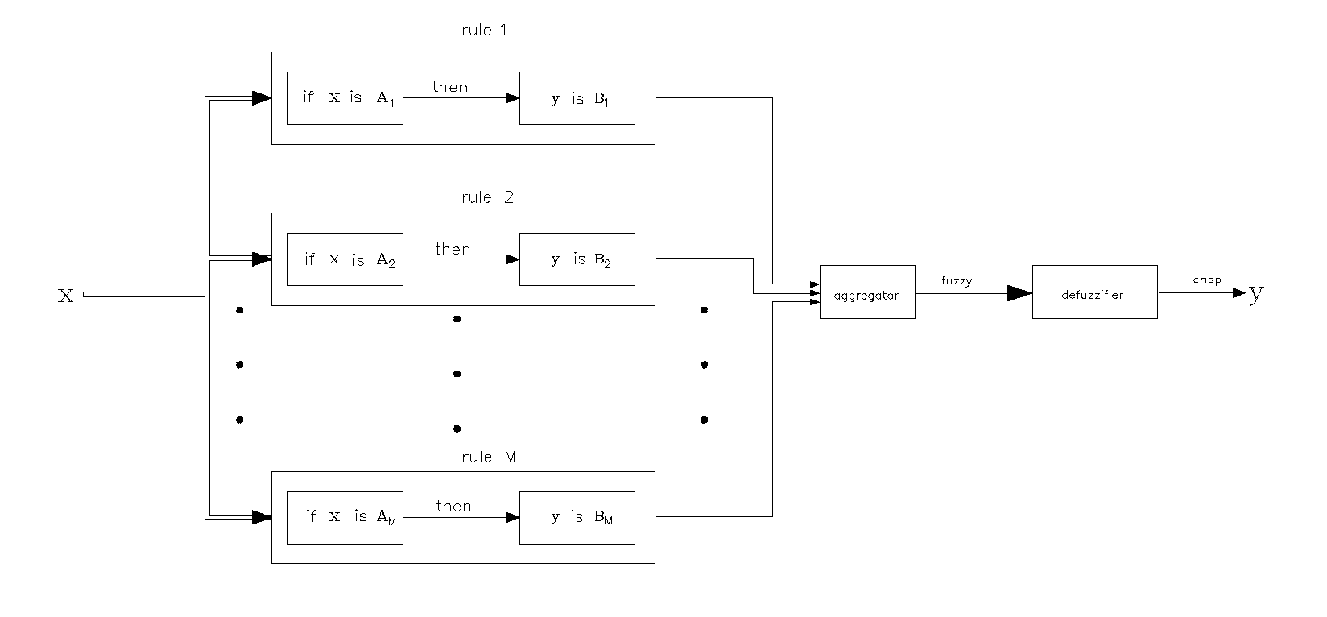
Fig. 5 The general form of fuzzy inference system

It consists of the rule base (left part of the system), the aggregation of the rules and the defuzzification, changing the fuzzy output to the crisp one. To the most known inference systems belong the Mamdani fuzzy model, Tsukamoto fuzzy model and Takagi - Sugeno - Kang (TSK) model [4,9,10,20 ]. In neuro-fuzzy networks most often used is the TSK model. A typical fuzzy rule in this model has the form [4]

if x₁ is A₁ AND x₂ is A₂ AND ... x_{N} is A_{N} then y=f(x) (14)

where $x={\left[x_{1},x_{2},\text{.}\text{.}\text{.},x_{N}\right]}^{T}$ and A₁, A₂, ..., A_{N} are fuzzy sets in the antecedent (the membership grades), while y is a crisp function in the consequent. The general function y=f(x) is a polynomial in the input variables x_{i}. We will apply here the linear form of this function, for which [20]
$y_{i}=f_{i}(x)=p_{i0}+\sum_{j=1}^{N}{p_{\text{ij}}}x_{j}$ (15)
of p_{ij} the adjustable parameters. Observe that the TSK fuzzy model does not need the defuzzification, since the f(x) is a crisp function. The aggregated value of the membership function μ_{i}(x) for the vector x in neuro-fuzzy networks is usually assumed in the form of a product.
For M fuzzy rules we have M such membership functions μ₁(x), μ₂(x), ..., μ_{M}(x). Assuming that each antecedent is followed by the consequent of the linear form of (15) for i= 1, 2, .., M, the aggregator of rules in TSK model generates the output crisp signal of the system as follows
$y(x)=\frac{\sum_{i=1}^{M}{μ_{i}(x)y_{i}(x)}}{\sum_{i=1}^{M}{μ_{i}(x)}}$ (16)
The last relation is called the universal approximation formula. This formula forms the basis for the practical implementation of the neuro-fuzzy networks.
6.2 TSK neuro-fuzzy network
The TSK fuzzy inference systems described by equation (16) can be easily implemented in the form of so called neuro-fuzzy network structure [4,6]. Fig. 6 presents the multilayer structure of the neuro-fuzzy network, realizing the TSK model of fuzzy system.
It is assumed that the TSK functions z_{i}, $z_{i}(x)=f(x)$ are linear of the following form
$z_{i}(x)=f_{i}(x)=p_{i0}+\sum_{j=1}^{N}{p_{\text{ij}}}x_{j}$ (17)
As a result of such assumption the values of f₁ and f₂ (output signals of two neurons of the 4th layer) are given as $f_{1}=\sum_{i=1}^{M}{μ_{i}(x)z_{i}}(x)$ and $f_{2}=\sum_{i=1}^{M}{μ_{i}}(x)$. In this way the final form of the approximation function performed by the network is given as follows

$y=f(x)=\frac{\sum_{i=1}^{M}{μ_{i}(x)\left(p_{i0}+\sum_{j=1}^{N}{p_{\text{ij}}x_{j}}\right)}}{\sum_{i=1}^{M}{μ_{i}(x)}}$ (18)

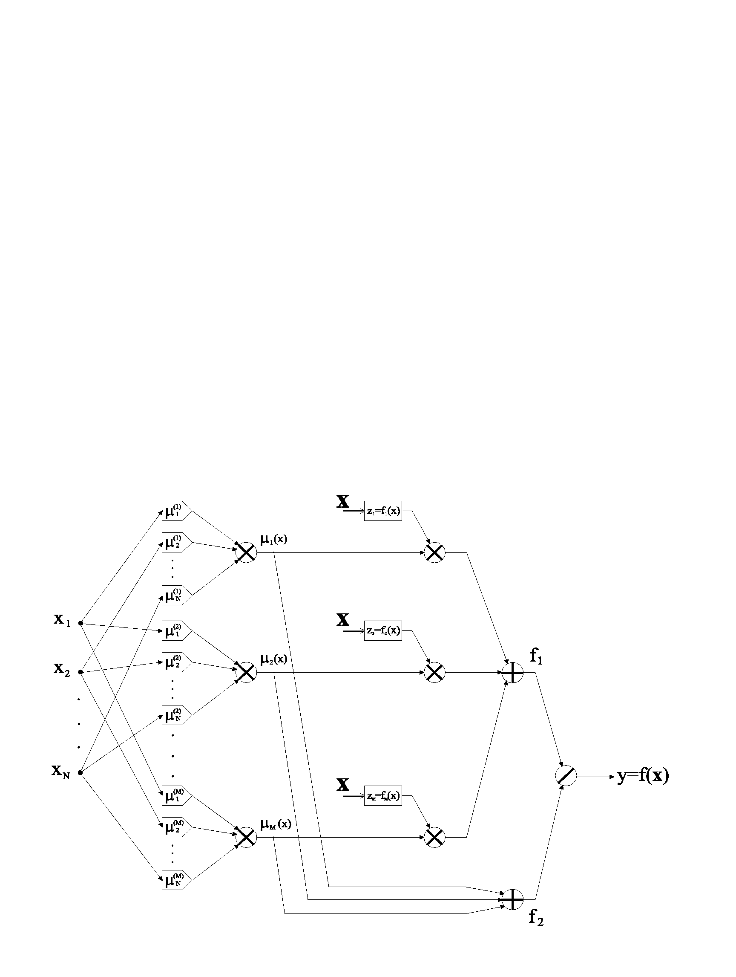
Fig. 6 The structure of neuro-fuzzy TSK model of fuzzy system

The adapted parameters of the network are the variables of the membership functions ,$σ_{j}^{(k)}$ , $b_{j}^{(k)}$ for j=1, 2, ..., M, and k = 1, 2, ..., N, and the coefficients (linear weights) p_{ij} for i = 1, 2, ..., M and j = 0, 1, 2, ..., N of the linear Takagi-Sugeno functions.
The network of Fig. 6 is of the multilayer form. The first layer performs the fuzzification according to the membership function μ_{j}(x_{j}), described by the relation (13). The second layer aggregates the fuzzified results of the individual scalar variables and creates the membership function of the vector x. This is the product type aggregation. Each node of this layer represents the firing strength of a rule. The third layer calculates the aggregated signals of the fuzzy inference for each inference rule (there are M of them). The output signal corresponding to each rule is the product of the firing strength of the rule and the consequent membership value. The fourth layer calculates only the sum of the signals of the third and second layers of the network. The final fifth layer contains only one output neuron. This neuron computes the overall output signal according to the relation (18).
Thus we have constructed the neuro-fuzzy network that is functionally equivalent to a Takagi-Sugeno fuzzy model. Only the first and third layers are parametric. The parameters of the first layer belong to the nonlinear functions and the weights p_{ij} of the third layer are linear.

6.3 Hybrid learning algorithm
The learning of the neuro-fuzzy network, that is the adaptation of the parameters of the first ($c_{j}^{(k)}$, $σ_{j}^{(k)}$, $b_{j}^{(k)}$) and third (p_{ij}) layers of the network can be implemented either in supervised or self-organizing mode. For the purpose of approximation more efficient and straighforward is the supervised one.
In practical implementation the most robust is the so-called hybrid approach [4,6]. In this method we take into account that the network is linear in the parameters p_{ij}, thus we can identify these parameters by a linear least squares method, based on a singular value decomposition. This is the first run of the learning stage.
In the second run we apply the steepest descent method for the estimation of the nonlinear parameters of the membership functions. Thus in the hybrid learning each iteration is composed of a forward pass and a backward one. In the forward pass, after the input vector is presented, we calculate the node outputs in the network layers and on the basis of this the linear parameters p_{ij} are adjusted using pseudoinverse, based on the SVD decomposition.
After linear parameters are identified we can compute the error on the output of the network corresponding to all data pairs, for the purpose of adaptation of the nonlinear parameters. In the backward pass the error signals propagate from the output end toward the input nodes. The gradient vector is calculated and the nonlinear parameters $c_{j}^{(k)}$, $σ_{j}^{(k)}$, $b_{j}^{(k)}$ updated by the steepest descent method. This process is repeated many times until there is a sufficient change of values of the adapted parameters of the network. In this way the training procedure is very similar to the training of RBF network.

6.4 Fuzzy self-organizing network
The important problem in efficient implementation of the learning of the fuzzy neural network is the combination of the individual 1-dimensional membership functions in each variable into the multidimensional membership rule. At N dimensions and m_{i} sections in ith variable, the number of possible rules is equal $\prod_{i=1}^{N}{m_{i}}$. Even at small m_{i} (say 3) and moderate dimension of the problem (say N=5) this means explosion of rules (in this case it will be 3⁵=243). Most of these rules are irrelevant since they correspond to the regions deprived of data. To avoid this problem it is possible to apply the self-organization to get the number of rules and at the same time the centers of the antecedent’s parts of these rules.
The self-organization algorithm called the c-means algorithm partitions the data space into fuzzy clusters. Each data point belongs to the particular cluster to some degree called the membership grade μ. The particular membership value of some data vector x_{j} to the set F_{i} is defined through the use of membership function $μ_{i}(x_{j})$. Similarly to the Kohonen case the fuzzy clustering partitions a collection of p vectors x_{j} into M fuzzy groups and finds a cluster center of each group such that a cost function of dissimilarity measure is minimized. Each vector x_{j} belongs at the same time to several groups with different degrees of membership, taking values from 0 to 1. The membership degrees $μ_{\text{ij}}=μ_{i}(x_{j})$ of the vector x_{j} to all M clusters fulfil the condition

$\sum_{i=1}^{M}{μ_{\text{ij}}}=1$ (19)

for all data vectors. Define the overall cost function as follows [4]

$E=\sum_{i=1}^{M}{\sum_{j=1}^{n}{μ_{\text{ij}}^{m}{\left\|x_{j}−c_{i}\right\|}^{2}}}$ (20)

with m - the weighting exponent, $m∈\left[1,∞\right]$ and c_{i} - the ith center vector. To reach the minimum of this cost we have to take into account the above constraint on the membership degrees. The necessary conditions for the minimum of the cost function E and satisfaction of the constraints on the membership degrees are as follows [4,21,22].

$c_{i}=\frac{\sum_{j=1}^{n}{η_{\text{ij}}^{m}x_{j}}}{\sum_{j=1}^{n}{η_{\text{ij}}^{m}}}$ (21)
and
$μ_{\text{ij}}=\frac{1}{\sum_{k=1}^{M}{{\left(\frac{d_{\text{ij}}}{d_{\text{kj}}}\right)}^{\frac{2}{m−1}}}}$ (22)

where d_{ij} is the Euclidean distance between center c_{i} and data vector x_{j}, $d_{\text{ij}}=\left\|c_{i}−x_{j}\right\|$. The fuzzy C-means clustering algorithm of the self-organization can be stated as follows [21,22].
- initialize the membership degrees $μ_{\text{ij}}$ for each cluster center with random values between 0 and 1 in such a way, that their sum for each vector x_{j} equals 1,
- find all M fuzzy cluster centers c_{i} using equation (21),
- calculate the cost function E described by (20); if E is below the assumed tolerance value or its improvement over previous iteration is negligible - stop, else go to next step,
- calculate new membership degrees $μ_{\text{ij}}$ using equation (22) and go to step 2.
This iterated procedure repeated many times leads to the minimum of E, which however is not necessarily the global minimum. The quality of solution is determined by the choice of the initial cluster centers following from the random values of the membership degrees $μ_{\text{ij}}$. The centers should be concentrated in these areas where most of the multidimensional data points are distributed. Only in the case of uniform distribution the placement of the centers is straighforward and should be also uniform. In other cases special methods of density distribution of data should be applied. The well knowns are mountain clustering method and subtractive clustering [9], allowing to get almost perfect fit of the initial cluster centers.

7. Examples of applications

7.1 Classification of the data points
The comparison of the efficiencies of the neural classifiers will be done on the classification task of the 3-dimensional data points forming three partly overlapping classes of different sizes. Fig. 7 presents the distribution of these data in the 3-D space.
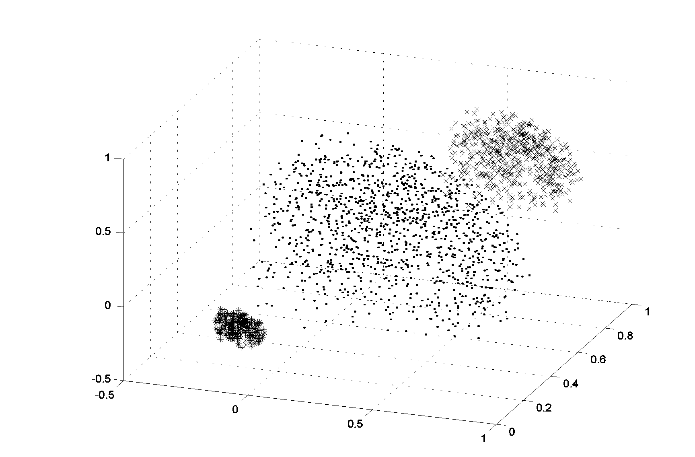

Fig. 7 The distribution of the 3D data belonging to three classes

There were 600 vectors belonging to the first class (dots), 100 vectors of second class (stars) and 300 vectors of the third class (x). Different types of neural networks have been learned and tested: the multilayer perceptron (MLP) of the structure 3-8-3 employing the bipolar sigmoidal neurons, classical Kohonen network of the structure 3-3, fuzzy self-organizing network of the same structure as Kohonen network and hybrid networks. Each network has been trained on the same set of 1000 learning data belonging to these 3 classes and then tested on another set of 1000 testing data.
From the simple networks the best was MLP, which has made 11 errors on the testing data (98.9% efficiency of recognition). The self-organizing layers were not efficient (Kohonen network -- 94 errors and fuzzy self-organizing layer -- 51 errors). Poor efficiency of simple self-organizing layers is due to the scarcity of synaptic weights in these networks as well as non-uniform and overlapping distribution of points belonging to different classes.
To improve the performance of the self-organizing networks (both Kohonen and fuzzy) we have combined them with the multilayer perceptron, creating the hybrid network (first self-organizing layer of 10 neurons and then MLP od the structure 10-8-3). The self-organizing layer performs the clusterization in 3-D space and MLP makes the final classification. The results of classification have been greatly improved now. The overall number of misclassified points has been reduced to 7 (99.3% efficiency) for Kohonen layer and to 6 (99.4 % efficiency) for fuzzy self-organizing layer. These experiments have confirmed the efficiency of the complex neural network structures in application to difficult classification tasks of the data, partly overlapping and belonging to the classes of different sizes and very close to each other in the N-dimensional space.

7.2 Gas measuring system
This application is concerned with the recognition of combustible or toxic gas pollutants using array of semiconductor oxide sensors and processing the obtained signals by neural networks [16]. As the pollutants we have considered 4 gases: carbon oxide, methane, propane/buthane and methanol vapor. As the sensors a small array of five semiconductor oxide sensing elements with various compositions is used. The sensor array has employed five sensors, namely TGS-815, TGS-822, TGS-842 Figaro sensors and NAP-11A, NAP-11AE Nemoto sensors. The array of these sensors was tested in an entirely computer controlled gas line. All measurements have been carried out with wet air (RH=70% at a temperature of 23º C) as carrier gas and with carbon oxide, methane, methanol vapors and propane/buthane as pollutants. The gas flux of 0.5 l/min was kept constant. The highest concentration of the pollutants did not exceed 1000 ppm. This array of sensors was exposed to various mixtures of air with these four pollutants [16].
The neural networks deal with the calibration of a system. Different types of networks have been checked: the MLP, the hybrid networks and the TSK neuro-fuzzy system. The training data set consisting of the measured sensor signals of known gas mixtures was used as the input for the network. A set of 80 further cases was used for testing. In both cases the sensor responses were normalized to the measured range.
To make the comparison exact we have calculated two kinds of errors: the mean absolute error (MAE) and mean absolute percentage error (MAPE). For each jth component of the mixture the MAE error is defined as

${\text{MAE}}_{j}=\frac{1}{p}\sum_{i=1}^{p}{|z_{i}^{\left(j\right)}}−r_{i}^{\left(j\right)}|$ (23)

where r_{j} means the real concentration of the jth gas component and z_{j} is the predicted value. The number of measurements for each gas component was equal p=20 in the testing mode, and j is the notation of the component (j=1, 2, 3, 4 in our experiments). On the basis of MAE for individual components we have also defined the average MAE error for the whole testing set.
The second measure of errors introduced in this work is the relative one, defined as the mean absolute percentage error. For each jth component it is defined as following:

${\text{MAPE}}_{j}=\frac{1}{p}\sum_{i=1}^{p}{\frac{\left|z_{j}^{\left(k\right)}−r_{j}^{\left(k\right)}\right|}{r_{j}^{(k)}}}$ (24)

Table 1 and 2 compare the results of testing the trained system for the measured samples of the mixture, composed of the four listed above gas components by applying different types of neural networks: two hybrid structures of the fuzzy clustering (c-means algorithm denoted here by the subscript FC) and the fuzzy Kohonen (FK) used for the self-organization, the MLP network and the TSK neuro-fuzzy network.

Table 1 Estimation errors of the fuzzy hybrid networks in the testing mode expressed as MAE and MAPE. Subscript FC means fuzzy clustering and FK - fuzzy Kohonen.

Gas | MAE_{FC} | MAPE_{FC} | MAE_{FK} | MAPE_{FK}
Methane | 2.16 ppm | 1.14% | 19.32 ppm | 5.62%
Carbon oxide | 4.28 ppm | 2.33% | 18.23 ppm | 4.21%
Methanol | 2.03 ppm | 1.11% | 13.57 ppm | 4.93%
Propan/butane | 1.84 ppm | 1.09% | 5.56 ppm | 2.43%
Mean | 2.59 ppm | 1.41% | 14.17 ppm | 4.30%

Table 2 Estimation errors of the MLP and TSK neuro-fuzzy networks in the testing mode
expressed as MAE and MAPE..

Gas | MAE_{MLP} | MAPE_{MLP} | MAE_{TSK} | MAPE_{TSK}
Methane | 19.52 ppm | 5.65% | 1.10 ppm | 0.37%
Carbon oxide | 10.21 ppm | 3.87% | 1.30 ppm | 0.65%
Methanol | 10.32 ppm | 4.21 | 1.99 ppm | 1.66%
Propan/butane | 18.13 ppm | 4.20% | 0.53 ppm | 0.54%
Mean | 14.54 ppm | 4.48% | 1.23 ppm | 0.81%

The applied MLP network, found as the optimal one, was of the structure 5-60-4. The hybrid network structures designed for the experiments were as follows 5-36-8-4 (fuzzy Kohonen layer) and 5-36-10-4 (fuzzy clustering layer). The TSK model used in the experiments consisted also of 5 inputs and 2 membership functions for each input (2⁵fuzzy rules). The number of nonlinear parameters was equal 30 and the number of linear parameters $p_{\text{ij}}$ equal $\text{32}⋅\text{ 6}⋅\text{ 4 }=\text{768}$. This makes 798 parameters altogether.

Fig. 8 The typical distribution of the estimation errors (in ppm) of the gas components in the mixture of gases

It is evidently seen that true fuzzy clustering applied in the hybrid network solution is much better than fuzzy Kohonen. The fuzziness of the FC is implemented in both the learning and testing phase while the FK network employs the fuzzy concept only at the stage of testing (the learning phase is a classical crisp self-organization). However the best of all was the TSK neuro-fuzzy network. The obtained accuracy for it is a few times better than that obtained by using any other network. The obtained mean MAPE errors at the testing mode for the particular solutions were as follows: 0.81% for TSK networks, 4.48% (MLP), 4.30% (hybrid fuzzy Kohonen) and 1.41% (hybrid fuzzy clustering).
Fig. 8 presents the typical distribution of testing errors at the estimation of the gas components (in ppm) for the mixtures of four gases, obtained by applying the TSK neuro-fuzzy networks used as the calibrator. As it is seen the maximum errors did not exceed the value of 10 ppm (the typical concentration level of the gases was around 1000 ppm).
7.3 The recognition of the heart beats on the basis of ECG waveforms
The last example presents the application of the fuzzy neural network for ECG beat recognition and classification [25,26]. The classification algorithm of the ECG beats presented here will apply the fuzzy hybrid neural network and will use the features drawn from the higher order statistics [24]. The cumulants of the second, third and fourth orders have been used for the feature selection.
The applied hybrid fuzzy neural network consists of true fuzzy self-organizing subnetwork connected in cascade with the multilayer perceptron, working as the final classifier. The c-means algorithm for the self-organization of the fuzzy neural network has been applied.
The most important point at any classification task is the preparation of the feature vector on the basis of which the recognition will be made. Only QRS complex of the ECG is taken into account at the selection of features. The examples of the normal sinus heart rhythms of the same patient (1000 QRS segments), taken from the MIT database [26] are shown in Fig. 9.

Fig. 9 The examples of the ECG waveforms of the normal sinus rhythm

Great variability of the waveforms is observed. To reduce this variablity of the waveforms belonging to the same class and at the same time to increase the differences among ECG waveforms belonging to different classes, the statistical preprocessing of the original ECG waveforms have been performed. The cumulants of the second, third and fourth orders have been calculated. The feature vector x used for the recognition of the beats has been selected as follows: five points representing each cumulant (2nd, 3rd and 4th orders) evenly distributed within the range of 30 lags around the R point, one element corresponding to the instantaneous RR interval of the beat, calculated as the difference between the QRS peak of the present and previous beats, one element representing the average RR interval of 10 last beats and one element corresponding to the width of the QRS complex. In this way each beat is stored as an 18-element vector, with the first 15 elements representing the statistically transformed QRS complex and the last three -- the temporary features of the actual QRS.
The information contained in the feature vectors of ECG beats has been applied to the input of the fuzzy hybrid neural network, which serves as the recognition and classification system. The input to the neural network is the set of vectors x_{i}, representing the features of the individual beats of different patients, for various types of beats, transformed according to the procedure described above. 15 different patients taken from the MIT/BIH arrhythmia database [26] have been considered in the experiments.
The ECG beats taking part in the classification have been splitted into two groups: one used only in learning and the separate one used only in the testing mode. The learning set contained 4035 pairs (the input vector x consisting of the features representing the beats and the destination vector d representing the code of the class) distributed among different patients and different types of beats. The testing set was formed of the 3150 pairs, corresponding to different beat types. Due to varied number of beats available in the MIT database the number of different beat types taking part in experiments, was changing.
Table 3 presents the results of testing the learned hybrid fuzzy neural network. The c-means algorithm was used for the adaptation of the self-organizing neurons. The structure of the network was as follows 18-30-8-7 (18 inputs, 30 fuzzy self-organizing neurons and the 30-8-7 MLP structure). The following seven types of heart beats have been recognized and classified: normal beat (N), left bundle branch block beat (L), right bundle branch block beat (R), atrial premature beat (A), premature ventricular contraction (V), ventricular flutter wave (I) and ventricular escape beat (E).

Table 3 The results of misclassifications of different rhythms on the testing ECG data
Type of rhythms | Number of rhythms | Misclassification number | Rate of misclassification
N | 1000 | 19 | 1.9%
L | 500 | 15 | 3%
R | 400 | 24 | 6%
A | 300 | 26 | 8.67%
V | 700 | 24 | 3.43%
I | 200 | 11 | 5.5%
E | 50 | 5 | 10%
Mean | 3150 | 124 | 3.94%

The results of recognition of different types of beats on the basis of the ECG waveforms have confirmed good efficiency of the proposed solution. The average rate misclassification of the system was below 4% at the testing mode.

8. Conclusions

The paper has presented the review of the most recent feedforward neural and neuro-fuzzy networks, including the multilayer perceptron, RBF networks, selforganizing competitive networks as well TSK and fuzzy self-organizing networks. The common feature of all these networks is the statistical processing of the input data. They represent processing of the signals in a parallel way to the classical approches.
All neural networks share the common feature, known as the generalization ability. Thanks to this property they are regarded as the branch of the artificial intelligence, able to learn and to use its knowledge to get the solution to the numerical data not seen at the learning phase.
The neural and neuro-fuzzy networks represent the most advanced way of signal processing, enabling to get the most accurate representation of the nonlinear dynamic problems. Generally, they fulfill the subsidiary role in most of applications, following from the universal approximation formula.
Dynamic development of neural network theory, observed in the last 15 years has enabled now to direct the main effort to the applications of them in different branches of technology, economy, medicine, etc. The classification of the patterns, prediction of the time series, estimation and identification of dynamic processes, calibration of the measuring units are the most important and typical tasks, that may be solved by using neural and neuro-fuzzy networks today.

References
- A. Cichocki, R. Unbehauen, Neural networks for optimization and signal processing, Wiley, N. Y., 1993
- G. Golub, C. Van Loan, Matrix computations, Academic Press, 1991, NY
- S. Haykin, Neural networks, a comprehensive approach, Macmillan Publishing Company, 1994, N. Y.
- J. R. Jang, C. T. Sun, E. Mizutani, Neuro-fuzzy and soft computing, Prentice Hall, 1997
- T. Kohonen, Self organization and associative memory, Springer Verlag, 1988
- S Osowski, Sieci neuronowe do przetwarzania informacji, Oficyna Wydawnicza PW, Warszawa, 2000
- R. Tadeusiewicz, Sieci neuronowe, Akademicka Oficyna Wydawnicza, Warszawa, 1993
- L. - X. Wang, Adaptive fuzzy systems and control; design and stability analysis, Prentice Hall, N. J., 1994.
- R. Yager, D. Filev, Podstawy modelowania i sterowania rozmytego; WNT, Warszawa, 1995.
- H. J. Zimmermann, Fuzzy set theory and its applications; Kluwer, Boston, 1985.
- S. Osowski, Fast second order learning algorithm for feedforward multilayer neural networks and its applications, Neural Networks, 1996, vol. 9, pp. 1583-1596
- M. Martinetz, S. Berkowich, K. Schulten, Neural gas network for vector quantization and its application to time series prediction, IEEE Trans. On Neural Networks, 1993, vol. 4, pp. 558 - 569
- R. Hecht-Nielsen, Counterpropagation networks, Applied Optics, 1987, vol.26, pp. 4979-4984
- K. Hornik, M. Stinchcombe, H. White, Multilayer feedforward networks are universal approximators, Neural Networks, 1989, vol. 2, pp. 359 - 366
- S. Amari, A. Cichocki, Adaptive blind signal processing - neural network approaches, Proceedings IEEE (invited paper), Vol. 86, No. 10, Oct. 1998, pp. 2026-2048
- S. Osowski, K. Brudzewski, Fuzzy self-organizing hybrid neural network for gas analysis system, IEEE Transactions on Measurements and Instrumentations, 2000, vol. 49, pp. 424-428
- Y. LeCun, J. Denker, S. Solla, Optimal brain damage, in "Advances in NIPS2", D. Touretzky, Ed., Morgan Kaufmann, San Mateo, 1990, pp. 598-605
- B. Hassibi, D. Stork, Second order derivatives for network prunning: optimal brain surgeon, in" Advances in NIPS5", D. Touretzky, Ed., Morgan Kaufmann, 1993, pp. 164-171, San Mateo
- L. Tran Hoai, Sieci neuronowe rozmyte w rozwiązaniu zadań klasyfikacji i estymacji, diss. PW, 2000
- T. Takagi, M. Sugeno, Fuzzy identification of systems and its application to modeling and control, IEEE Trans. SMC, 1985, pp. 116 – 132
- J. C. Bezdek, Pattern recognition with fuzzy objective function, Plenum Press, N. Y. 1981
- R. Babuska, H. B. Verbruggen, Constructing fuzzy models by product space clustering, (in "Fuzzy model identification", H. Hellendoorn, D. Driankov, Eds., Springer, Berlin, 1998), pp. 53 - 90
- A. Nikias, A. Petropulu, Higher order spectral analysis, Prentice Hall, N. J., 1993
- L. Zadeh, Fuzzy sets, Information and control, 1965, pp. 338-353
- Y. Hen Hu, S. Palreddy, W. Tompkins, A patient adaptable ECG beat classifier using a mixture of experts approach, IEEE Trans. Biomedical Engineering, 1997, vol. 44, pp. 891 - 900
- R. Mark, G. Moody, MIT-BIH arrhythmia database directory, MIT, 1988

